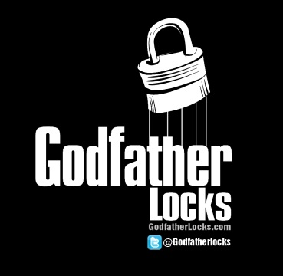
Super Bowl 50 Prop Sheet

Name: ______________________________

- Will the coin toss be heads or tails? ____________________

- Will the first offensive play from scrimmage be a pass or a run? ________________

- Which team will get a first down first? ________________

- Will a punt or field goal be blocked? ______________

- Which team will call the game’s first timeout? _______________

- Will a kickoff or punt be run back for a touchdown? _______________

- Which team will sack the quarterback first? _______________

- Which team will score first? _______________

- Which team will score the first touchdown? _______________

- What is the Final Score? Denver ________ Carolina ________

